Game Design Document

Fill up the Following document

1. Write the title of your project.

Simple Flappy Birds

1. What is the goal of the game?

In my version, to get 40 points.

1. Write a brief story of your game?

A bird needs to get out of a giant cage, to do that the bird must fly up and down to get past some obstacles, which are columns. The bird must get past 40 of these obstacles to get out of the cage.

1. Which are the playing characters of this game?

* Playing characters are the ones which respond to the user based on the input from the user.
* Cars, monkeys, dinos, wizards etc. are the playing characters in the game.

|  |  |  |
| --- | --- | --- |
| Number | Character Name | What can this character do? |
| 1 | The Bird | It can fly up and down. |
| 2 |  | . |
| 3 |  |  |
| 4 |  |  |
| 3 |  |  |
| 4 |  |  |
| 5 |  |  |
| 6 |  |  |
| 7 |  |  |
| 8 |  |  |

1. Which are the Non Playing Characters of this game?

* Non Playing characters are the ones which don't have an action or a behaviour when the user interacts with the game.
* Hurdles, stones, bananas, coins, etc. are non playing characters in the game.

|  |  |  |
| --- | --- | --- |
| Number | Character Name | What can this character do? |
| 1 | The Obstacles | Stays in place and sometimes moves and changes direction. |
| 2 | Mario | A little guy that comes up at the end of the game and throws stuff at you. |
| 3 | Carnivorous Plant Obstacles | Come and stuff up after a period of time. |
| 4 |  |  |
| 5 |  |  |
| 6 |  |  |
| 7 |  |  |

1. Draw your imagination of this game. What does this game look like?

* Draw the game either on your computer or on paper,
* Add images of scenes of the game to show each of the playing and non-playing characters at least once.

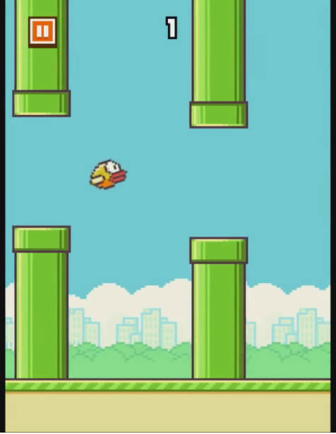

Click this link or copy and paste. It is a YouTube video: [Flappy Bird Gameplay - YouTube](https://www.youtube.com/watch?v=fQoJZuBwrkU)

1. Development Tools

Visual Studio Code

1. Required Libraries

matter.js

p5.dom.min.js

p5.js

p5.play.js

p5.sound.min

Addition:

I added 1 thing that comes up at the end of the game - Mario. He will make the game much more interesting to play.